# Requirement Understanding and story creation on JIRA Board

Go through all stories, epics and design documents and understand the project requirement.

If have any query or question get back to either BA or Architect.

Create stories on JIRA board or ask BA to create for you as below:

## 1.1. Structure Creation and Building Blocks

Description:- Structure definition, Application and Project creation including folders and ResourceNegSvc Service setup.

**Note**: I used point it as 1-2 pointer

## 1.2. Create "New OSB service name" Pipeline

I am taking example of **ProviderExclusionOrchestration**

Description:- Create request and response XSD,Create Proxy and Pipeline for "ProviderExclusionOrchestration" do transformation and Invoke "ProviderExclusionService" JAX-WS.

<http://10.200.131.65:7001/ProviderExclusionServiceWeb/ProviderExclusionService?WSDL>

**Note**: I used to point it as 2-3 pointer based on logic complexity

## 1.3. Create Work Managers and Max Threads in WebLogic Server.

Description:- Create Work Managers and Max Threads for Proxy and Business Services in Console.

**Note**: I used to point it as 1 pointer

## 1.4. Create generic Customization file for newly created OSB service

Example **ProviderExclusionOrchestration**

Description:- Create single deployment profile for ProviderExclusionOrchestration.

**Note**: I used to point it as 1 pointer

## 1.5. Do GSLB setup for newly created JAX-RS

Description:- Add New Apache HTTP Location Tags.

**Note**: I used to point it as 1 pointer

## 1.6. Create GIT repository and Jenkins job for new OSB project

ex. ProviderExclusionOrchestration

Description:- GIT repository, Jenkins job creation for new OSB project ProviderExclusionOrchestration and deployment.

**Note**: I used to point it as 2 pointer

# Create OSB/SOA project

While naming project name or related artifacts follow same naming convention as what is mentioned in design doc or in work flow.

When you are creating new OSB project then below things need to follow-

## 2.1 Create folder structure by following FNX standards

Below OSB service can be used as reference purpose. Create folder structures as per below standard.

FNX Best Practices and Standard:- https://confluence.multiplan.com/display/SOAPG/Service+Bus+Logging+Best+Practices

**Browser** [**url:-**](url:-)<http://gitscm.multiplan.com/#/admin/projects/OON/OSB/FNX/NegotiationPortalBulkProposalOrchestration>

**GIT Location:-** http://gitscm.multiplan.com/OON/OSB/FNX/NegotiationPortalBulkProposalOrchestration

Folder structure:-

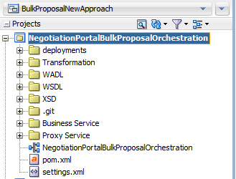

## 2.2 Update POM file

When you create new OSB project then it creates automatically 1 pom file with it’s default contents.

We have to update its content as below-

Let’s say default content is as below-

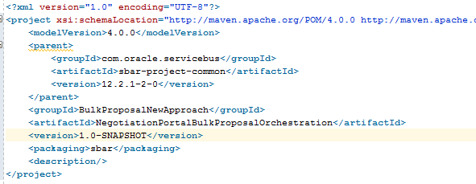

Replace it with below content-

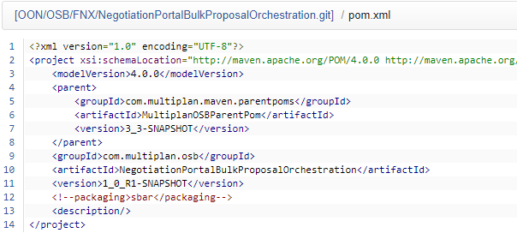

Note:- Here we replaced Parent GroupId with Multiplan’s details. ArtifactId will be same as OSB project name and initial version will be **1_0_R1-SNAPSHOT**. **Comment** packaging sbar otherwise during deployment it will break. You can get pom content from GIT location that I provided above.

## 2.3 Add settings.xml file

We have to add settings.xml file in our new project otherwise it will break during creating Jenkins build.

Copy the file from above GIT location and put it in your new OSB project and modify details as per your project.

Content-

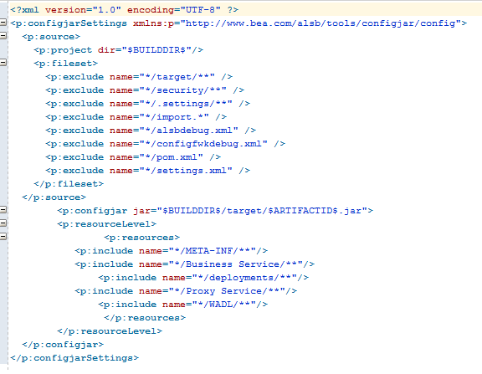

## 2.4 WebLogic Configurations

Sometimes as per our need we have to create new Cluster, New Data Source, JMS Queue and Work Managers in WebLogic.

For creating Data Source and Managed Server/ Cluster in WebLogic follow this story:- <https://jira.multiplan.com/browse/FNX-61576>

## 2.5 FNX WebLogic Domains

We have following WebLogic Domains, Can be found at this link http://mwweb.multiplan.com/

### 2.5.1. EntMessaging_Domain

We create JMS Queue/Topics inside EntMessaging_Domain and inside EntMessaging JMS Module.

WebLogic(Dev):- <http://walvdevmpwl2151.multiplan.com:40060/console/login/LoginForm.jsp>

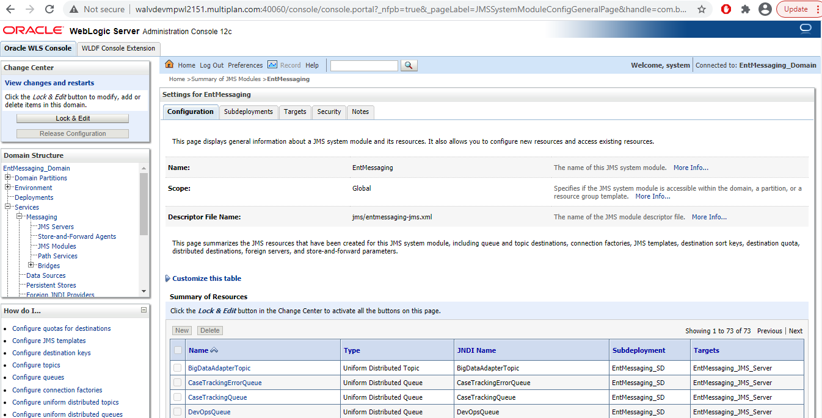

### 2.5.2 FeeNegSvc_Domain

We deploy Java services (JAX-RS/JAX-WS) and create Java Data Sources inside this Domain.

WebLogic(Dev):- http://walvdevmpwl2202.multiplan.com:60070/console/login/LoginForm.jsp

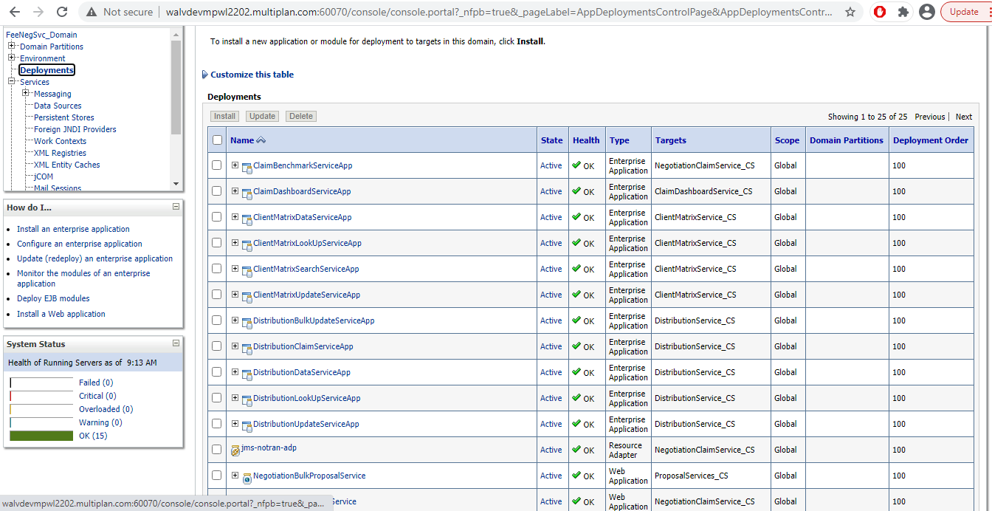

Data Sources-

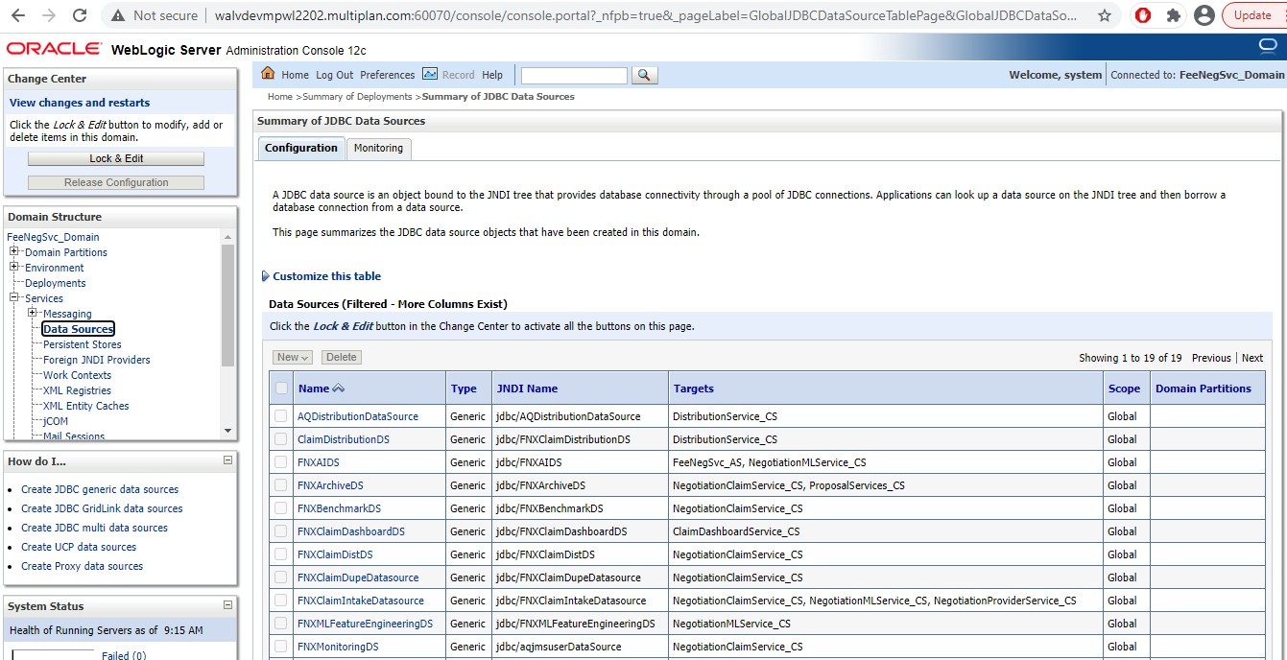

### 2.5.3 FeeSvcSOA Domain

Inside this domain we deploy our SOA and OSB services, Data Sources and Work Managers(For Business Service and Proxy Service) that is required for SOA/OSB service.

WebLogic(Dev):- <http://walvdevmpwl2202.multiplan.com:60080/console/login/LoginForm.jsp>

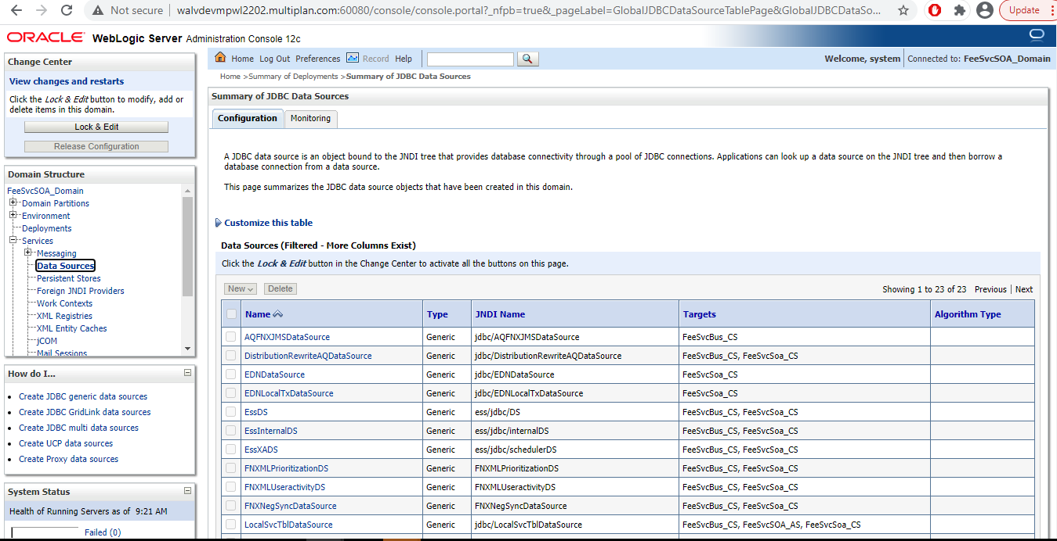

## 2.6 Work Manager and Max Threads

Create Work Managers and Max Threads for newly created Business Services and Proxy Services.

Creation of Work Manager is automated by SCM Team via Jenkins Job.

Steps:-

1. Go Check-out the Work Manager Folder from GIT Location at your local:- [**http://gitscm.multiplan.com/DevOps/Automation/MW/WorkManager.git**](http://gitscm.multiplan.com/DevOps/Automation/MW/WorkManager.git)
2. Go to Folder specific to FNX release version

Now add the Work Manager/Max Threads details as per requirement in file **\WorkManager\FNX_21.5\FeeSvcSOA_Domain\FeeSvcBus_CS\WM-FeeSvcBus_CS.properties**

1. Save and Check-in/Commit the file using any user story that is assigned to you in JIRA.
2. Now build Work Manager in dev environment using below Jenkins job

Work Manager Build Job:- [**http://nap-bld-srv:8081/view/MPI_2.0/job/MW_Automations/job/WorkManager/job/MW_WorkManager_Dev/**](http://nap-bld-srv:8081/view/MPI_2.0/job/MW_Automations/job/WorkManager/job/MW_WorkManager_Dev/)

Log in with your Multiplan Credentials and select the release_version(as per FNX release, here I chosed FNX_21.5 as this code will be deployed in May release,2021), Technology as “OSB” and profile as “feeSvcDomain12c” select

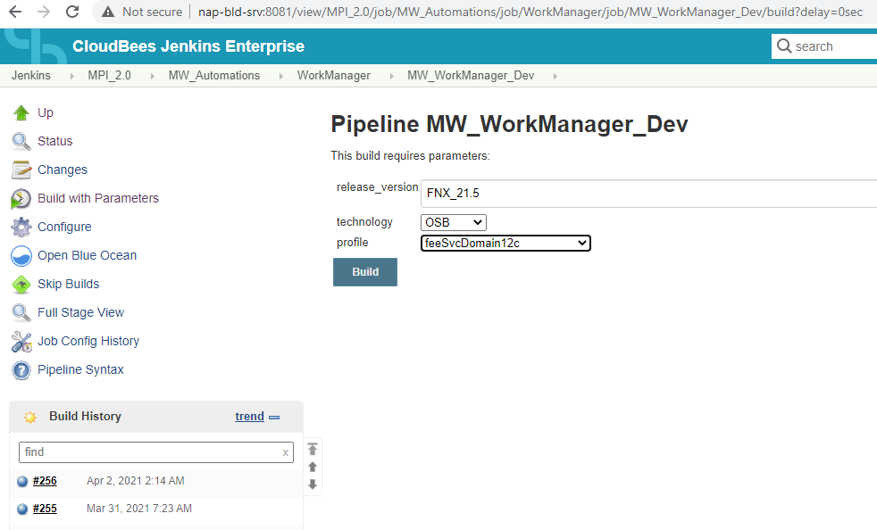

1. Now stage the Work Manager file for higher env. Deployment using below Jenkins Job:-

**http://nap-bld-srv:8081/view/MPI_2.0/job/MW_Automations/job/WorkManager/job/MW_WorkManager_Staging/**

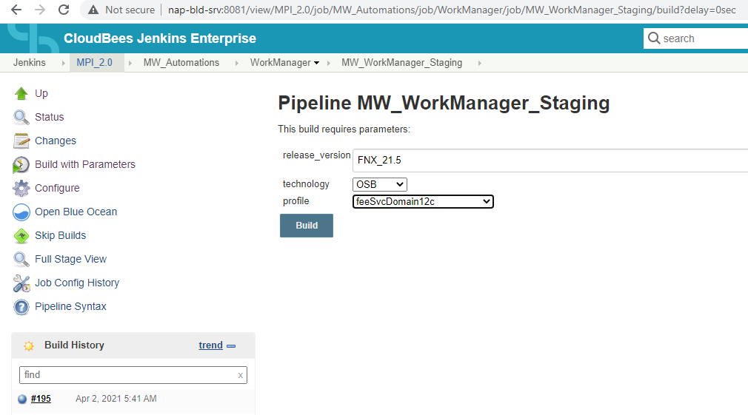

1. After stage is completed cross check whether file is staged in FNX_21.5 folder or not by going into below path-

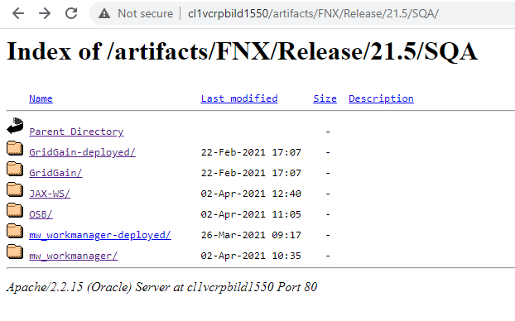

Here I verified in SQA 21.5 folder and inside **mw_workManager/** folder there was that property file.

Create a CR and create a task as Autodeploy and put all the required information for Work Manager

**For detailed refer CTASK# CTASK0204135**

# Steps for creating new OSB service

## New cluster creation in FeeNegSVC Domain

If there is need for new cluster then follow below steps and raise a ticket to middleware for creating new cluster in FeeNegSVC Domain for newly created JAX-RS

Short Description: Create new cluster in FeeNegSvc_Domain

Description:

Domain: FeeNegSvc_Domain

Details:-

Cluster Name: BulkProposalService_CS

SrNo. Managed Servers. Listen Address. Port. SSL Listen Port.

1. BulkProposalService_MS1 cl1vregmpwl2187/10.168.47.217 60096 60097

2. BulkProposalService_MS2 cl1vregmpwl2188/10.168.47.218 60096 60097

Please use rest of the properties same as what we have for ProposalServices_CS.

**For more details follow CTASK#** CTASK0209980

## Develop new OSB service

Develop new OSB service and do the unit testing on local and follow all the FNX standards as mentioned in step 2.1

## JMS Queue creation

Create a ticket for Middleware and put the details as below and replace JMS Queue name as per requirement.

JMS Queue creation

Sub:- Define and configure JMS queues/servers in ENTMessaging Domain

Create JMS Queues into ENTMessaging Domain

1.

In EntMessaging Domian -> JMS Modules -> EntMessaging-> create new session ->

• Domain: ENTMessaging_Domain

• Queue Name: FNXBulkProposalErrorQueue

• Queue type: Uniform Distributed Queue

• QUEUE JNDI: FNXBulkProposalErrorQueue

• Sub Deployment: ENTMessaging_SD

• Targets: EntMessaging_JMS_Server

Click Next

Click Finish

Activate the Changes

2.

In EntMessaging Domian -> JMS Modules -> EntMessaging-> create new session ->

• Domain: ENTMessaging_Domain

• Queue Name: FNXBulkProposalQueue

• Queue type: Uniform Distributed Queue

• QUEUE JNDI: FNXBulkProposalQueue

• Sub Deployment: ENTMessaging_SD

• Targets: EntMessaging_JMS_Server

• Redelivery Delay Override: 12000

• Redelivery Limit: 0

• Expiration Policy: Redirect

• Error Destination: FNXBulkProposalErrorQueue

Click Next

Click Finish

Activate the Changes

**For more details follow CTASK#** [CTASK0204113](https://multiplan.service-now.com/change_task.do?sys_id=d1720e731bfb64904f092f4a234bcb08&sysparm_record_target=change_task&sysparm_record_row=1&sysparm_record_rows=74&sysparm_record_list=state%21%3D8%5Echange_request%3D1f3b8857db5b68d064e09047db9619cd%5EORDERBYu_task_order)

## Data Source creation

**Data Source Creation for FeeNegSvc Domain(Java Domain)**

Create below Data Source that is required for Java service and replace names as per requirement in below:

Short description: Create a Generic Oracle data source in FeeNegSvc Domain

We need to create a Generic Oracle data source in FeeNegSvc Domain.

DataSource name : FNXPortalBulkProposalDS

JNDI name : jdbc/FNXPortalBulkProposalDS

Application user : MPIFNX_USER

Password : please get it from the DBA

JDBC URL: jdbc:oracle:thin:@ldap://mpilxauth.multiplan.com:389/nxdbs01fnx,cn=OracleContext,dc=multiplan,dc=db

Target: ProposalServices_CS

Connection Pool max connections: 15

Statement Timeout: -1

Inactive Connection Timeout: 10 (sec)

Connection Reserve Timeout: 10 (sec)

**For more details follow CTASK#** [CTASK0204115](https://multiplan.service-now.com/change_task.do?sys_id=7af28ab31bfb64904f092f4a234bcb4b&sysparm_record_target=change_task&sysparm_record_row=3&sysparm_record_rows=74&sysparm_record_list=state%21%3D8%5Echange_request%3D1f3b8857db5b68d064e09047db9619cd%5EORDERBYu_task_order)

**Data Source Creation for FeeSVCSOA Domain(SOA/OSB Domain)**

Create DataSource "FNXMLPrioritizationDS" in FeeSvcSOA_Domain.

Short description: Create SOA-OSB DataSources in FeeSvcSOA_Domain

Description:

1."FNXMLPrioritizationDS".

Details:-

DataSource name: FNXMLPrioritizationDS

JNDI name: FNXMLPrioritizationDS

Application user: MPIFNX_USER

Password: please get it from the DBA

JDBC URL: jdbc:oracle:thin:@ldap://mpilxauth.multiplan.com:389/nxdbs01fnx,cn=OracleContext,dc=multiplan,dc=db

Target: FeeSvcBus_CS, FeeSvcSoa_CS

Connection Pool max connections: 15

Statement Timeout: 10 (sec)

Inactive Connection Timeout: 10 (sec)

Connection Reserve Timeout: 10 (sec)

Supports Global Transactions: false

**For more info refer CTASK# CTASK0167150**

## Create Outbound Connection Pool for AQ Adapter

Short Description: Create Outbound Connection Pool for AQ Adapter in FeeSvcSOA_Domain

Description:

Go to Domain_Structure and Click on "Deployments" option.

Click on "AQAdapter"

Click on "Configuration" tab and then click on "Outbound Connection Pools" sub Tab.

Click New, select "javax.resource.cci.ConnectionFactory" and click New

Fill JNDI Name: "eis/fnx/FNXMLPrioritizationDS" and Finish.

Again go to "Outbound Connection Pool Configuration Table" and expand "javax.resource.cci.ConnectionFactory".

Click on "eis/fnx/FNXMLPrioritizationDS" and fill the DataSourceName as "FNXMLPrioritizationDS" and leave rest as default.

Click Enter button in Key Board and click save.

Again go to Domain_Structure and Click on "Deployments" option.

Select "AQAdapter" and click on Update Button.

Select "Redeploy this application using the following deployment files:" and click on Next.

And Finish.

Activate the Changes

**For more info refer CTASK#** [CTASK0167381](https://multiplan.service-now.com/change_task.do?sys_id=64292266dbb51c547aee7dc88c9619fb&sysparm_record_target=change_task&sysparm_record_row=17&sysparm_record_rows=67&sysparm_record_list=state%21%3D8%5Echange_request%3D0d5ecae4dbad10500b48f5361d9619d9%5EORDERBYu_task_order)

Dev DataBase jdbc URL: jdbc:oracle:thin:@ldap://mpilxauth.multiplan.com:389/dvnxdbs01gen,cn=OracleContext,dc=multiplan,dc=db

## Add New Apache HTTP Location Tag for newly created Java service

Raise a ticket to Middleware and put short description as below:

Short Description: Add New Apache HTTP Location Tags.

Decsription:

Add New Apache HTTP Location Tags

Domain:- FeeNegSvc

1. Java Service name (ex. NegotiationBulkProposalService )

Cluster:- Cluster name where service will be deployed (ex. BulkProposalService_CS)

<Location /NegotiationBulkProposalService>

SetHandler weblogic-handler

SetHandler weblogic-handler

WLSRequest On

WebLogicCluster mpnegssvc01-gslb:60096

</Location>

(Note: If service url is: http://walvdevmpwl2117.multiplan.com:60096/NegotiationBulkProposalService/PingService then it's location tag would be "NegotiationBulkProposalService")

After above configuration testable Url:- <http://mpnegssvc01-gslb.dev.mpigslb/NegotiationBulkProposalService/PingService>

For more info refer CTASK# [CTASK0204114](https://multiplan.service-now.com/change_task.do?sys_id=99c2c6b31bfb64904f092f4a234bcbc6&sysparm_record_target=change_task&sysparm_record_row=4&sysparm_record_rows=74&sysparm_record_list=state%21%3D8%5Echange_request%3D1f3b8857db5b68d064e09047db9619cd%5EORDERBYu_task_order)

## Work Manager Creation for Proxy and Business Services created in new OSB service

Follow steps above from 2.6

## Jenkins Governance Script changes

Before deploying our OSB service there might be some properties (Business Service Retry Count, Retry iteration interval, Read Time Out etc.) those are not up to standard of FNX, so there might be some exception that we have to setup in Customization file. To stop from breaking in Jenkins Build Job for our services we have to add exceptions so that Jenkins Governance Script that will verify all the components for services during Jenkins job build.

Check-Out below folder- <http://gitscm.multiplan.com/Architecture/GovernanceScripts/Exceptions.git>

Open excel sheet and do the necessary changes by following this file

Follow all steps mentioned in Confluence- [**https://confluence.multiplan.com/display/PMPI20/OSB+Governance+Script**](https://confluence.multiplan.com/display/PMPI20/OSB+Governance+Script)

## Create Customization file

Before deploying code into Dev environment we have to create Customization File.

You can create customization file via your Local SB Console and then you can replace the properties(Like Work Manager name, HTTP URL, Retry Count, Time Out value etc.)

Login to your SB Console, Go to Admin Tab, Click Create, and Click on Create Configuration File then 1 POP window will open, select you OSB project name and then click on Create. 1 OSB Customization file will get downloaded at your downloading folder. Open the .xml file and replace values as per your need.

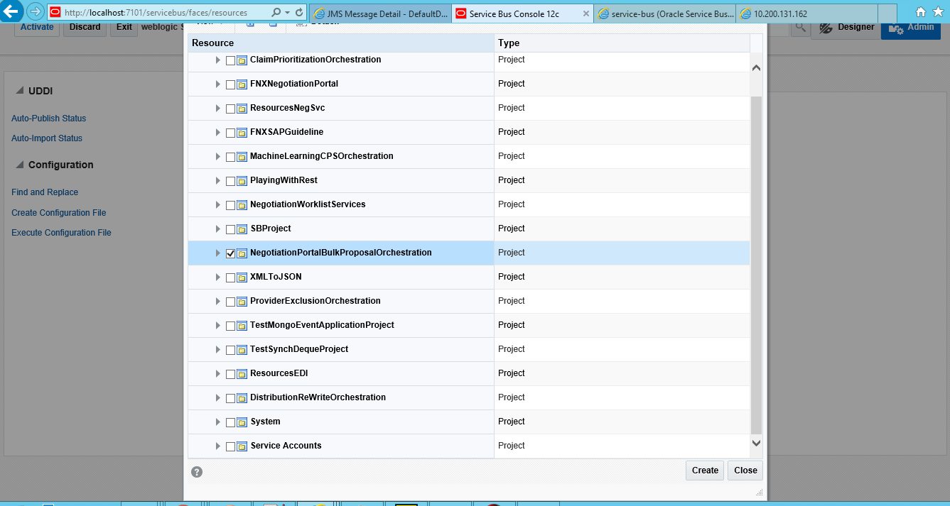

Name the file same as what we have OSB project name and save it inside deployments folder and check-in the code to GIT repository.

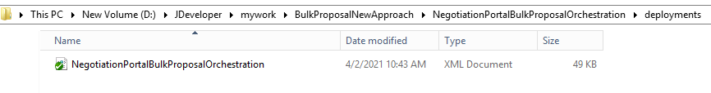

## Create New Jenkins Jobs for Build and Stage

Follow all the steps mentioned in Confluence page and create new Jenkins Build and Staging Jobs.

[**https://confluence.multiplan.com/display/DUKE/Howto+-+Create+Jenkins+job**](https://confluence.multiplan.com/display/DUKE/Howto+-+Create+Jenkins+job)

For FNX-OSB we create Build Jobs at below location

<http://nap-bld-srv:8081/job/OSB/job/OSB_DEV/job/FeeSvcBUS/>

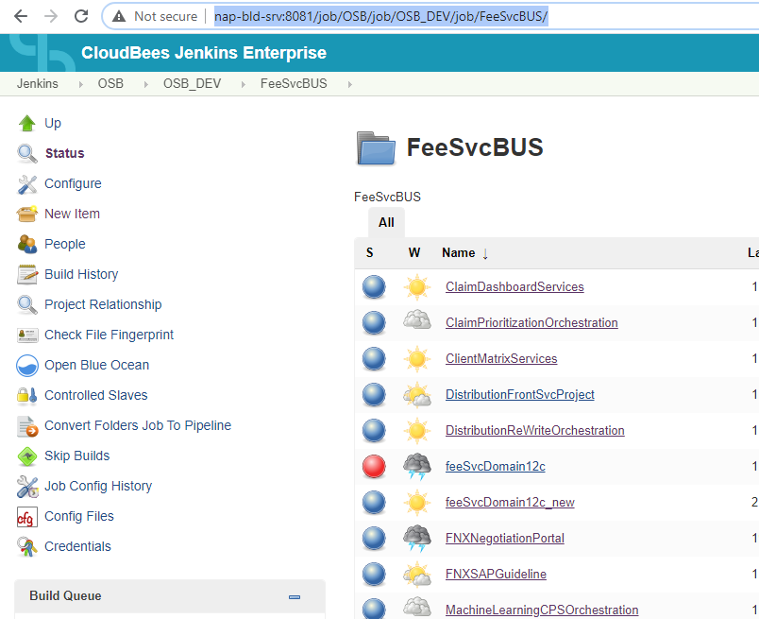

Staging Jobs at below location-

[**http://nap-bld-srv:8081/job/OSB/job/OSB_Staging/job/FeeSvcBUS/**](http://nap-bld-srv:8081/job/OSB/job/OSB_Staging/job/FeeSvcBUS/)

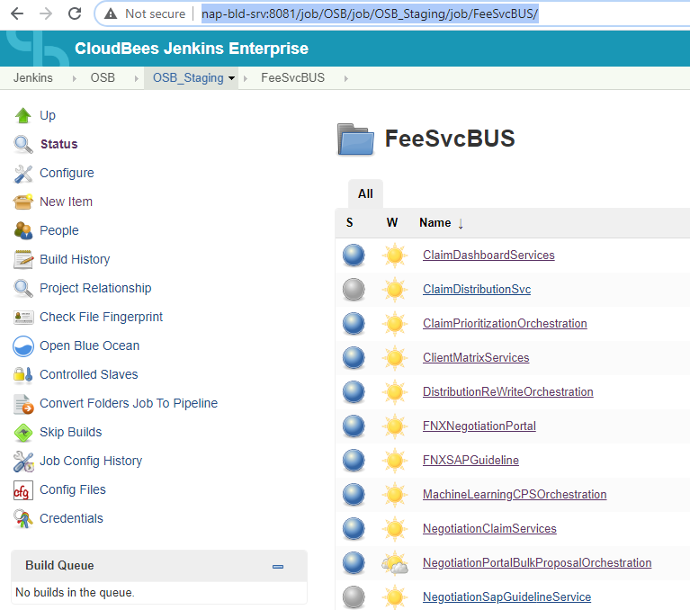

## Create Oracle Advance Queue

Creating new Oracle Advance Queue in Data Base we can follow below script at GIT location-

[**http://gitscm.multiplan.com/plugins/gitblit/blob/?r=Common/Oracle/Mpi_aqadm.git&f=DDL/aq_fnxmlpriorityscore.sql&h=Release-2.0**](http://gitscm.multiplan.com/plugins/gitblit/blob/?r=Common/Oracle/Mpi_aqadm.git&f=DDL/aq_fnxmlpriorityscore.sql&h=Release-2.0)

Create Object Type, use this Object type while creating Advance Queue Table and then create Oracle Advance Queue using this table.

What could be elements in Object Type you can get details from our Architect Freddie.

## Create Jenkins deployment profile for newly created cluster

* Creation of Jenkins "Deployment Profile" for the newly created WebLogic Cluster we will create new Jenkins "Deployment Profile".

System:   FeeNegSvc_Domain

Create a deploymentProfile called "FNX.BulkProposalService" needed for new JAX service deployments on new cluster i.e. “BulkProposalSercice_CS”.

When you create new Jenkins job for Build then in “**deploymentProfile**” field just put FNX.[Cluster name that you created exclude “**_CS**”] ex. FNX.BulkProposalService

It will automatically start deploying your code into this new cluster.

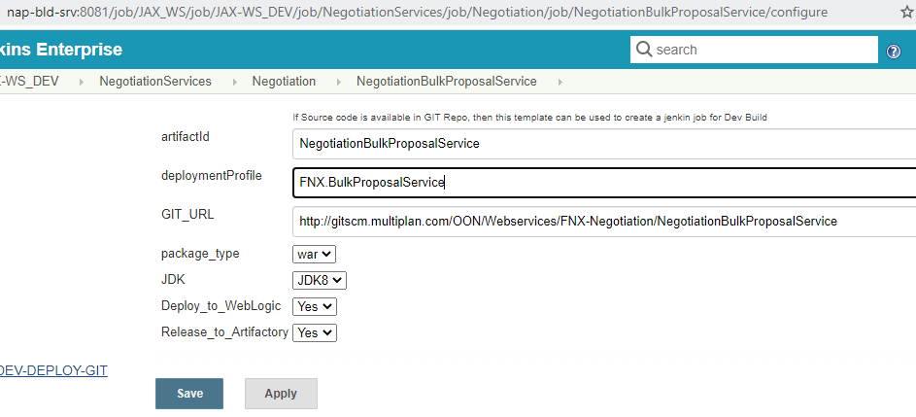

# 4. Deploy Code into higher environment

Build your project via Jenkins Job

Go to SCM location url and inside your OSB project - <http://nap-bld-srv:8081/job/OSB/job/OSB_DEV/job/FeeSvcBUS/job/NegotiationPortalBulkProposalOrchestration/build?delay=0sec>

For example If it is “**NegotiationPortalBulkProposalOrchestration**”.Login and click on “**Build with Parameters**”. Select GIT Branch and click on Build.

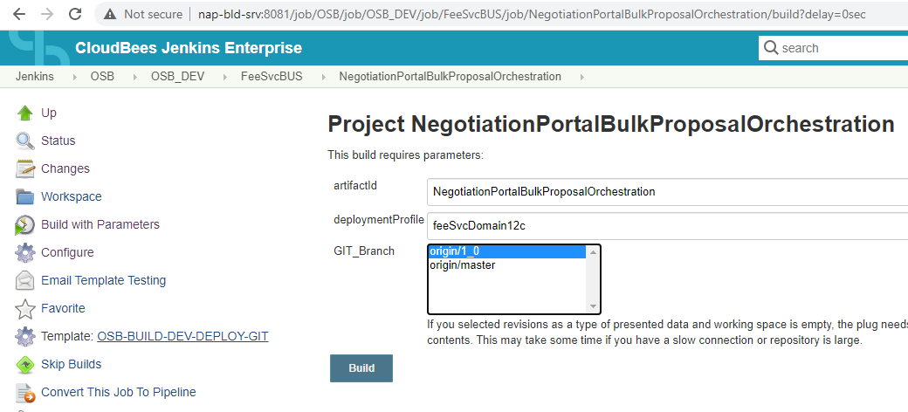

After Build is Success-We will have to stage the project into staging folder.

Copy value of artifactVersion from Build.

Open the Build(Here it is #29) and go to Console Output and do a search with “artifactVersion” and copy the blue highlighted texts.

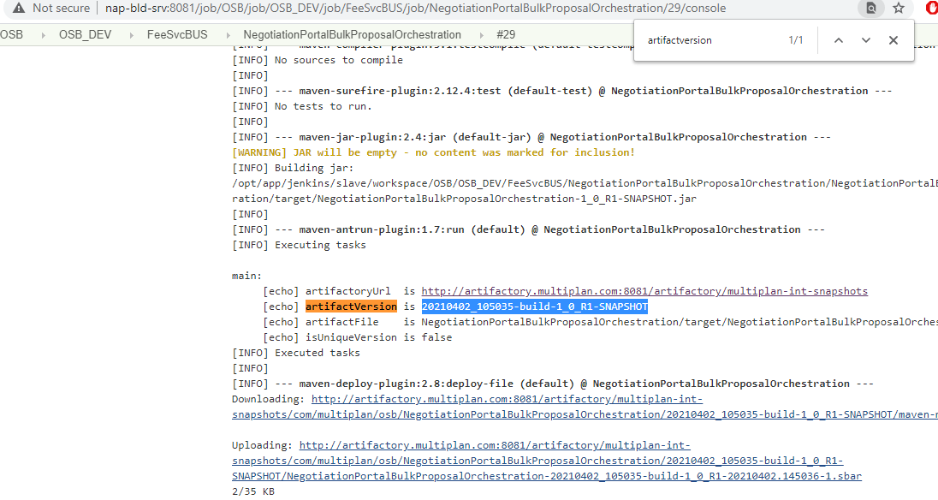

Now open Staging Job for the same project:-

<http://nap-bld-srv:8081/job/OSB/job/OSB_Staging/job/FeeSvcBUS/job/NegotiationPortalBulkProposalOrchestration/build?delay=0sec>

For example I it is “**NegotiationPortalBulkProposalOrchestration**”.Login and click on “**Build with Parameters**”. Paste the artifactVersion what you copied from previous build inside “Version” field,release_version(Is the folder where you will be staging) and Select GIT_Branch, click on Build.

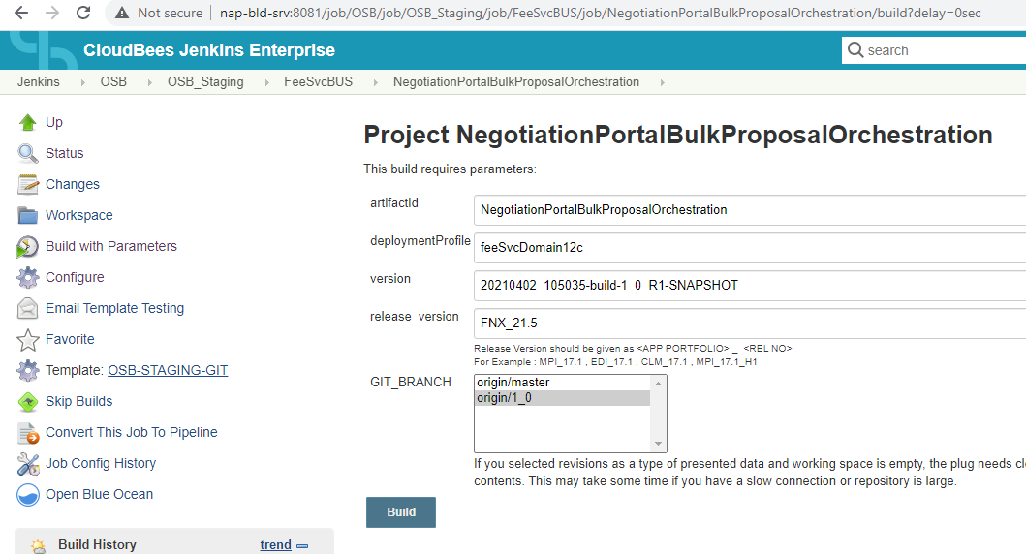

Once Build is Success go to staging Folder and we can check whether our artifact is there or not.

BAT, PROD and STG staging location:- <http://cl1vcrpbild1415/artifacts/FNX/Release/>

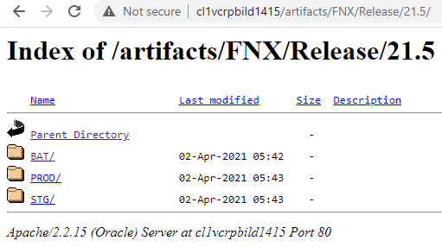

REG, SQA and CIT staging location:- <http://cl1vcrpbild1550/artifacts/FNX/Release/21.5/>

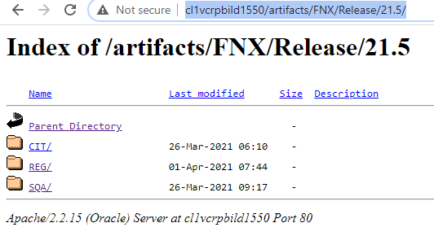

# 5. GSLB

## 5.1 For JAVA services (mpnegssvc01-gslb)

We access all JAX-RS/JAX-WS services via gslb instead of environment specific urls.

JAX-RS: http://mpnegssvc01-gslb.dev.mpigslb/NegotiationBulkProposalService/PingService?parameter=Test

JAX-WS: <http://mpnegssvc01-gslb.sqa.mpigslb/DistributionClaimServiceWeb/DistributionClaimServiceImplService?wsdl>

## 5.2 Messaging Services(mpmsngsvc01-gslb, mpmsngsvc02-gslb)

These GSLBs are for connecting EntMessaging JMS Queue from EntMessaging JMS Module.

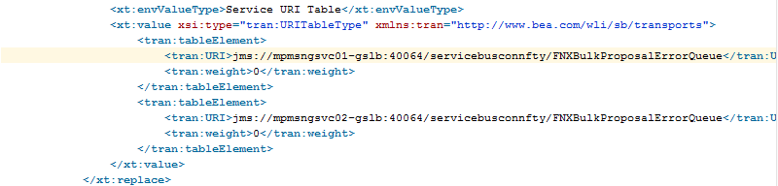

## 5.3 OSB Services (mppfnxbus01-gslb)

<http://mppfnxbus01-gslb.reg.mpigslb/services/ProviderExclusionSvc?WSDL>

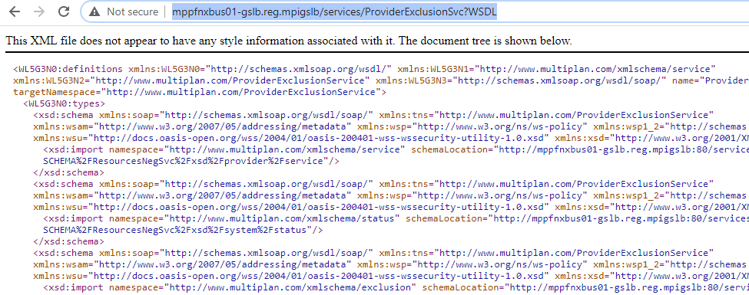

## 5.4 SOA Services (mppfnxsoa01-gslb)

<http://mppfnxsoa01-gslb.dev.mpigslb/soa-infra/services/default/FNXNegotiationsBpel/FNSNegotiationsBPELProcessClient_ep?WSDL>

For Accessing SOA services we use **mppfnxsoa01-gslb**

## 5.5 .Net portal Services (mpfnxptl01-gslb)

To connect portal .net services we use <http://mpfnxptl01-gslb.dev.mpigslb/negotiationPortal/Service.svc?wsdl>

# 6. Miscellaneous Topics

## 6.1 Alias LookUp

Alias-Look Up is the portal where we can find details of the cluster/node/server which is associated with specific GSLB and environment.

Go to:- <http://mwweb.multiplan.com:8080/>

Put GSLB in “Service Alias” field, select environment and click on Lookup Alias button. You will find all the Servers those are connected with mppfnxbus01 GSLB in Dev environment.

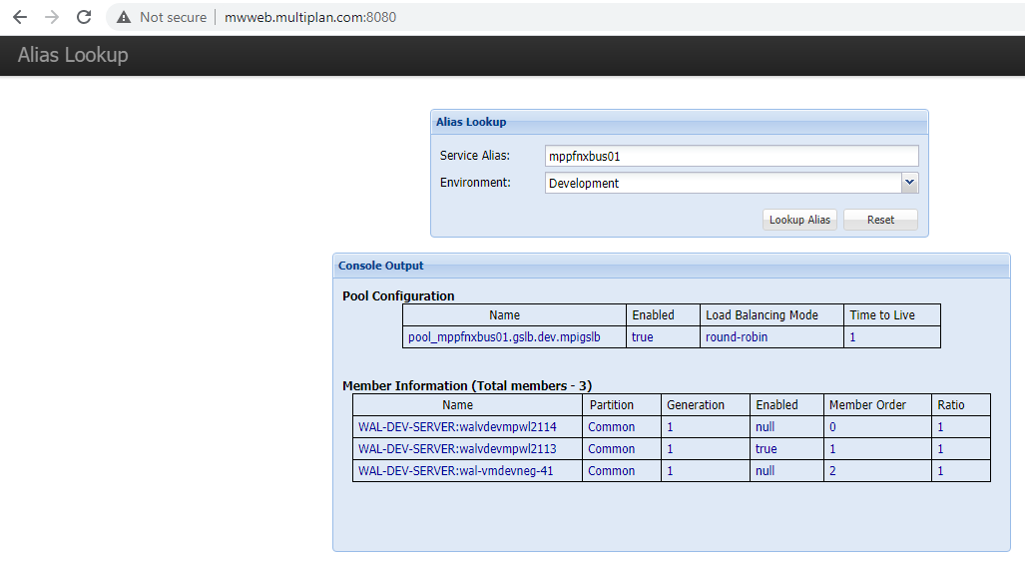

## 6.2 MDS Setup for SOA

We have only 1 MDS repository in FNX that ResourceNegSvc service(Which works as common repository for OSB as too)

Git location: <http://gitscm.multiplan.com/OON/OSB/FNX/ResourcesNegSvc>

Pull code for SOA service: http://gitscm.multiplan.com/OON/SOA/FNX/FNXNegotiationsProject

Open it in JDeveloper then go to Resources tab and then open properties of **SOA_DesignTimeRepository**-

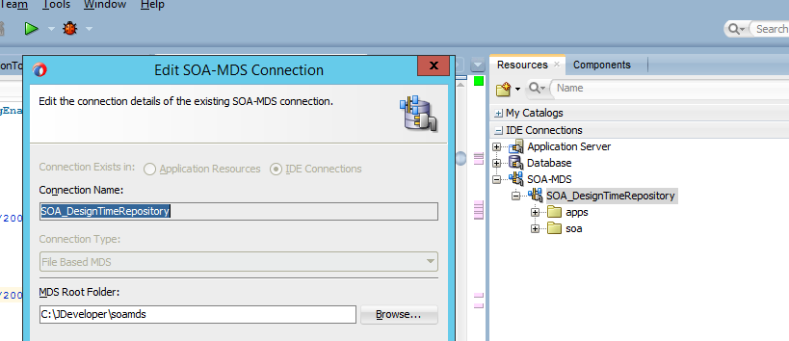

Now go to that MDS Root Folder here it is C:\JDeveloper\soamds

And Pull code of ResourceNegSvc service.

Then go to your SOA service and open adf-config.xml into Notepad++

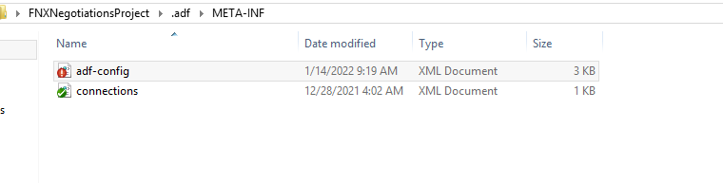

**Replace entire file content with below content:**

Below we are targeting File based contents so during Check-in **DO NOT PUSH THIS FILE.**

<?xml version="1.0" encoding="windows-1252" ?>

<adf-config xmlns="http://xmlns.oracle.com/adf/config"

xmlns:config="http://xmlns.oracle.com/bc4j/configuration"

xmlns:adf="http://xmlns.oracle.com/adf/config/properties"

xmlns:sec="http://xmlns.oracle.com/adf/security/config">

<adf-adfm-config xmlns="http://xmlns.oracle.com/adfm/config">

<defaults useBindVarsForViewCriteriaLiterals="true" changeEventPolicy="ppr" useBindValuesInFindByKey="true"

iteratorRowValidationFlag="false"/>

<startup>

<amconfig-overrides>

<config:Database jbo.locking.mode="optimistic"/>

</amconfig-overrides>

</startup>

</adf-adfm-config>

<adf:adf-properties-child xmlns="http://xmlns.oracle.com/adf/config/properties">

<adf-property name="adfAppUID" value="FNXNegotiationsProject-2533"/>

</adf:adf-properties-child>

<sec:adf-security-child xmlns="http://xmlns.oracle.com/adf/security/config">

<CredentialStoreContext credentialStoreClass="oracle.adf.share.security.providers.jps.CSFCredentialStore"

credentialStoreLocation="../../src/META-INF/jps-config.xml"/>

</sec:adf-security-child>

<adf-mds-config xmlns="http://xmlns.oracle.com/adf/mds/config">

<mds-config xmlns="http://xmlns.oracle.com/mds/config">

<persistence-config>

<metadata-namespaces>

<namespace path="/soa" metadata-store-usage="mstore-usage_1"/>

<namespace path="/apps" metadata-store-usage="dev_mds"/>

</metadata-namespaces>

<metadata-store-usages>

<!--

<metadata-store-usage id="dev_mds">

<metadata-store class-name="oracle.mds.persistence.stores.db.DBMetadataStore">

<property name="jdbc-userid" value="DEV_MDS"/>

<property name="jdbc-password" value="welcome1"/>

<property name="jdbc-url" value="jdbc:oracle:thin:@10.150.14.239:1521:xe"/>

<property name="partition-name" value="soa-infra"/>

</metadata-store>

</metadata-store-usage>

-->

<metadata-store-usage id="dev_mds">

<metadata-store class-name="oracle.mds.persistence.stores.file.FileMetadataStore">

<property name="metadata-path"

value="C:\JDeveloper\soamds"/>

<!--<property name="partition-name" value="seed"/>-->

</metadata-store>

</metadata-store-usage>

<metadata-store-usage id="mstore-usage_1">

<metadata-store class-name="oracle.mds.persistence.stores.file.FileMetadataStore">

<property name="metadata-path"

value="C:\JDeveloper\soamds"/>

<!--<property name="partition-name" value="seed"/> -->

</metadata-store>

</metadata-store-usage>

</metadata-store-usages>

</persistence-config>

</mds-config>

</adf-mds-config>

</adf-config>

When you do changes into ResourceNegSvc and you need to deploy it as MDS make sure you are making hard build from mdsPom.xml file

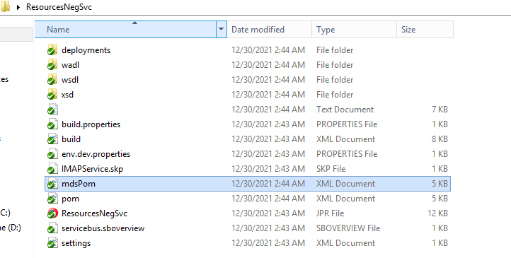

For deploying, you will have to first BUILD it via Jenkins Job: <http://napvcrpbild1148:8081/job/SOA/job/SOA_MDS_DEV/job/ResourcesNegSvc/>

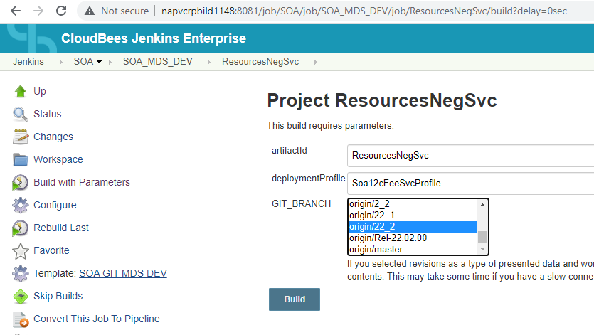

Once build is completed got to MDS staging Jenkins job and stage it for higher environment deployment:

<http://napvcrpbild1148:8081/job/SOA/job/SOA_MDS_Staging/job/ResourcesNegSvc/>

Enter Snapshot/HardBuild version in Version field (You can get it from above BUILD job by searching with artifactVersion in Build-Console), Enter release version and select Git branch which you want to stage.

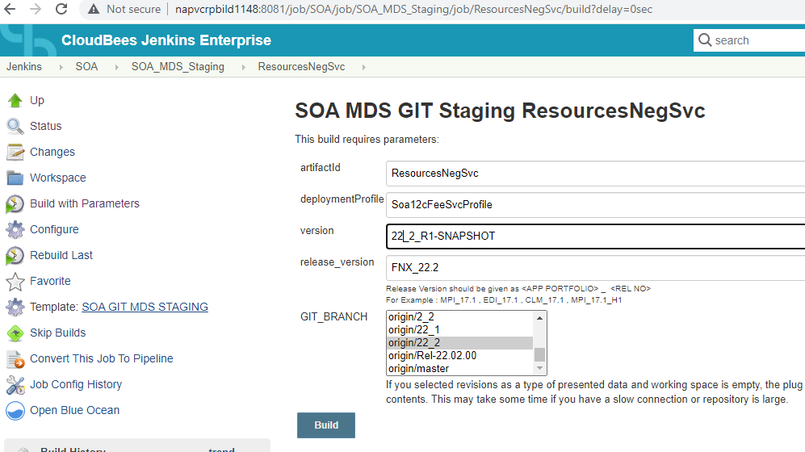

# 7. Log Files

We can check server logs at below urls-

## 7.1 Java Logs

Java Logs can be accessed with below url-

Dev Environment-

1.[http://walvdevmpwl2117.multiplan.com/logs/](http://walvdevmpwl2117.multiplan.com/logs/FeeNegSvc_Domain/)

2. [http://walvdevmpwl2118.multiplan.com/logs/](http://walvdevmpwl2118.multiplan.com/logs/FeeNegSvc_Domain/)

SQA Environment-

1. http://cl1vsqampwl2161.multiplan.com/logs/

2. <http://cl1vsqampwl2162.multiplan.com/logs/>

BAT Environment-

1. http://walvuatmpwl2165.multiplan.com/logs/

REG Environment-

1. http://cl1vregmpwl2187.multiplan.com/logs/

2. http://cl1vregmpwl2188.multiplan.com/logs/

STG/TRN Environment-

1. http://walvstgmpwl3464.multiplan.com/logs/

2. http://walvstgmpwl3465.multiplan.com/logs/

CIT/EDI Environment-

1. http://cl1vedimpwl2197.multiplan.com/logs/

PROD Environment-

1. http://cl1vprompwl2193.multiplan.com/logs/

2. <http://cl1vprompwl2194.multiplan.com/logs/>

## JMS Queue Server Logs

JMS Queue Logs can be accessed at this url-

Dev Environment-

1. <http://walvdevmpwl2133.multiplan.com/logs/EntMessaging_Domain/EntMessaging_MS1.out>

2. <http://walvdevmpwl2134.multiplan.com/logs/EntMessaging_Domain/EntMessaging_MS2.out>

SQA Environment-

1. http://cl1vsqampwl2277.multiplan.com/logs/EntMessaging_Domain/EntMessaging_MS1.out

2. http://cl1vsqampwl2278.multiplan.com/logs/EntMessaging_Domain/EntMessaging_MS2.out

BAT Environment-

1. http://walvuatmpwl2319.multiplan.com/logs/EntMessaging_Domain/EntMessaging_MS1.out

REG Environment-

1. http://cl1vregmpwl2247.multiplan.com/logs/EntMessaging_Domain/EntMessaging_MS1.out

2. http://cl1vregmpwl2248.multiplan.com/logs/EntMessaging_Domain/EntMessaging_MS2.out

STG/TRN Environment-

1. http://walvtrnmpwl2335.multiplan.com/logs/EntMessaging_Domain/EntMessaging_MS1.out

2. http://walvstgmpwl3450.multiplan.com/logs/EntMessaging_Domain/EntMessaging_MS2.out

CIT/EDI Environment-

1. http://cl1vedimpwl2387.multiplan.com/logs/EntMessaging_Domain/EntMessaging_MS1.out

2. http://cl1vedimpwl2388.multiplan.com/logs/EntMessaging_Domain/EntMessaging_MS2.out

PROD Environment-

1. http://cl1vprompwl2357.multiplan.com/logs/EntMessaging_Domain/EntMessaging_MS1.out

2. <http://cl1vprompwl2358.multiplan.com/logs/EntMessaging_Domain/EntMessaging_MS2.out>

## OSB Logs

OSB Logs can be accessed at this url-

Dev Environment-

1. http://walvdevmpwl2113.multiplan.com/logs/FeeSvcSOA_Domain/FeeSvcBus_MS1.out

2. <http://walvdevmpwl2114.multiplan.com/logs/FeeSvcSOA_Domain/FeeSvcBus_MS2.out>

SQA Environment-

1. http://cl1vsqampwl2157.multiplan.com/logs/FeeSvcSOA_Domain/FeeSvcBus_MS1.out

2. http://cl1vsqampwl2158.multiplan.com/logs/FeeSvcSOA_Domain/FeeSvcBus_MS2.out

BAT Environment-

1. http://walvuatmpwl2163.multiplan.com/logs/FeeSvcSOA_Domain/FeeSvcBus_MS1.out

REG Environment-

1. http://cl1vregmpwl2183.multiplan.com/logs/FeeSvcSOA_Domain/FeeSvcBus_MS1.out

2. http://cl1vregmpwl2184.multiplan.com/logs/FeeSvcSOA_Domain/FeeSvcBus_MS2.out

STG/TRN Environment-

1. http://walvstgmpwl3468.multiplan.com/logs/FeeSvcSOA_Domain/FeeSvcBus_MS1.out

2. http://walvstgmpwl3469.multiplan.com/logs/FeeSvcSOA_Domain/FeeSvcBus_MS2.out

CIT/EDI Environment-

1. http://cl1vedimpwl2195.multiplan.com/logs/FeeSvcSOA_Domain/FeeSvcBus_MS1.out

PROD Environment-

1. http://cl1vprompwl2189.multiplan.com/logs/FeeSvcSOA_Domain/FeeSvcBus_MS1.out

2. <http://cl1vprompwl2190.multiplan.com/logs/FeeSvcSOA_Domain/FeeSvcBus_MS2.out>

## SOA Logs

Java Logs can be accessed at this url-

Dev Environment-

1. http://walvdevmpwl2115.multiplan.com/logs/FeeSvcSOA_Domain/FeeSvcSoa_MS1.out

2. <http://walvdevmpwl2116.multiplan.com/logs/FeeSvcSOA_Domain/FeeSvcSoa_MS2.out>

SQA Environment-

1. http://cl1vsqampwl2159.multiplan.com/logs/FeeSvcSOA_Domain/FeeSvcSoa_MS1.out

2. http://cl1vsqampwl2160.multiplan.com/logs/FeeSvcSOA_Domain/FeeSvcSoa_MS2.out

BAT Environment-

1. http://walvuatmpwl2164.multiplan.com/logs/FeeSvcSOA_Domain/FeeSvcSoa_MS1.out

REG Environment-

1. http://cl1vregmpwl2185.multiplan.com/logs/FeeSvcSOA_Domain/FeeSvcSoa_MS1.out

2. http://cl1vregmpwl2186.multiplan.com/logs/FeeSvcSOA_Domain/FeeSvcSoa_MS2.out

STG/TRN Environment-

1. http://walvstgmpwl3470.multiplan.com/logs/FeeSvcSOA_Domain/FeeSvcSoa_MS1.out

2. http://walvstgmpwl3471.multiplan.com/logs/FeeSvcSOA_Domain/FeeSvcSoa_MS2.out

CIT/EDI Environment-

1. http://cl1vedimpwl2196.multiplan.com/logs/FeeSvcSOA_Domain/FeeSvcSoa_MS1.out

PROD Environment-

1. http://cl1vprompwl2191.multiplan.com/logs/FeeSvcSOA_Domain/FeeSvcSoa_MS1.out

2. http://cl1vprompwl2192.multiplan.com/logs/FeeSvcSOA_Domain/FeeSvcSoa_MS2.out

# 8. OSB/SOA Consoles

Below are the useful consoles that we use while building OSB/SOA composites-

## 8.1 Dev Environment-

1. WebLogic Server- http://walvdevmpwl2202.multiplan.com:60080/console/
2. EM Console- http://walvdevmpwl2202.multiplan.com:60080/em
3. SB Console- <http://walvdevmpwl2202.multiplan.com:60080/servicebus>

## 8.2 SQA Environment-

1. WebLogic Server- http://cl1vsqampwl2203.multiplan.com:60080/console
2. EM Console- http://cl1vsqampwl2203.multiplan.com:60080/em
3. SB Console- <http://cl1vsqampwl2203.multiplan.com:60080/servicebus>

## 8.3 BAT/UAT Environment-

1. WebLogic Server- http://walvuatmpwl2204.multiplan.com:60080/console
2. EM Console- http://walvuatmpwl2204.multiplan.com:60080/em
3. SB Console- <http://walvuatmpwl2204.multiplan.com:60080/servicebus>

## 8.4 REG Environment-

1. WebLogic Server- http://cl1vregmpwl2205.multiplan.com:60080/console
2. EM Console- http://cl1vregmpwl2205.multiplan.com:60080/em
3. SB Console- <http://cl1vregmpwl2205.multiplan.com:60080/servicebus>

## 8.5 STG/TRN Environment-

1. WebLogic Server-http://walvstgmpwl3463.multiplan.com:60080/console
2. EM Console-http://walvstgmpwl3463.multiplan.com:60080/em
3. SB Console-http://walvstgmpwl3463.multiplan.com:60080/servicebus

## 8.6 CIT/EDI Environment-

1. WebLogic Server- http://cl1vedimpwl2207.multiplan.com:60080/console
2. EM Console- http://cl1vedimpwl2207.multiplan.com:60080/em
3. SB Console- <http://cl1vedimpwl2207.multiplan.com:60080/servicebus>

## 8.7 PROD Environment-

1. WebLogic Server-http://cl1vprompwl2206.multiplan.com:60080/console
2. EM Console-http://cl1vprompwl2206.multiplan.com:60080/em
3. SB Console-http://cl1vprompwl2206.multiplan.com:60080/servicebus

# 9. FNX/CNX Email Boxes

We have Email Boxes to which OSB Lister listens and processes the messages.

Below are the email boxes (get the password from Dmitriy which you need to work)-

1. FNX:- DEV

Email:- [dev.view@multiplan.com](mailto:dev.view@multiplan.com)

username: Dev.View

1. CNX:- DEV

Email:- Dev.Portal@marsauditor.com

username : msadevportal

1. CNX:- SQA

Email:- SQA.Portal@marsauditor.com

Username: MSASQAPortal

1. CNX:- REG

Email:- [Reg.Portal@marsauditor.com](mailto:Reg.Portal@marsauditor.com)

Username: MSARegPortal

1. CNX:- UAT

Email:- Uat.Portal@marsauditor.com

Username: msauatportal

1. CNX:- EDI/CIT

Email:- [Edi.Portal@marsauditor.com](mailto:Edi.Portal@marsauditor.com)

Username: MSAEdiPortal

1. CNX:- STG

Email:- [stg.portal@marsauditor.com](mailto:stg.portal@marsauditor.com)

Username: msastgportal

1. CNX:- PROD

Email:- Portal@marsauditor.com (PROD/DR)

Username: MSAPortal

1. CNX-PROD Support

[portal_support@marsauditor.com](mailto:portal_support@marsauditor.com)

Username: MSAPortalSupport

1. FNX:- STG

Email:- [stg.view@multiplan.com](mailto:stg.view@multiplan.com)

UserName:- msastgview

1. CNX:- BAT

UserName – MSAbatportal

Email ID - [bat.portal@marsauditor.com](mailto:bat.portal@marsauditor.com)

1. CNX:- CIT

Account – MSAcitportal

EmailID - [cit.portal@marsauditor.com](mailto:cit.portal@marsauditor.com)

1. CIT Global referral

Account- MSAcitGlobalReferral

Email ID - [cit.Global_Referral@multiplan.com](mailto:cit.Global_Referral@multiplan.com)

1. FNX:- BAT

Account – MSAbatview

Email ID - [bat.view@multiplan.com](mailto:bat.view@multiplan.com)

1. FNX:- CIT

Account – MSAcitview

Email ID - [cit.view@multiplan.com](mailto:cit.view@multiplan.com)

1. CIT FNX-Support

Account - MSAcitviewsupport

Email ID - [cit.view_support@multiplan.com](mailto:cit.view_support@multiplan.com)

Below 2 are the Email Listeners (Both are inside FNXNegotiationPortal OSB Service) that listens to FNX and CNX email boxes-

Listens to CNX Email Box-**FNXNegotiationPortal\Proxy\CNXEmailListenerProxy.proxy**

Listens to FNX Email Box- **FNXNegotiationPortal\Proxy\EmailListenerProxy.proxy**

# 10. Un-staging artifact from staging location

If you want to un-stage any artifact from staging folder then we can achieve it by un-staging via Jenkins job.

Go to <http://nap-bld-srv:8081/view/MPI_2.0/job/MISC/job/Artifact_Unstaging/build>

And Login via your credentials, put release version, select environment, technology and artifact id.

Click on Build button then it will be deleted from staging location.

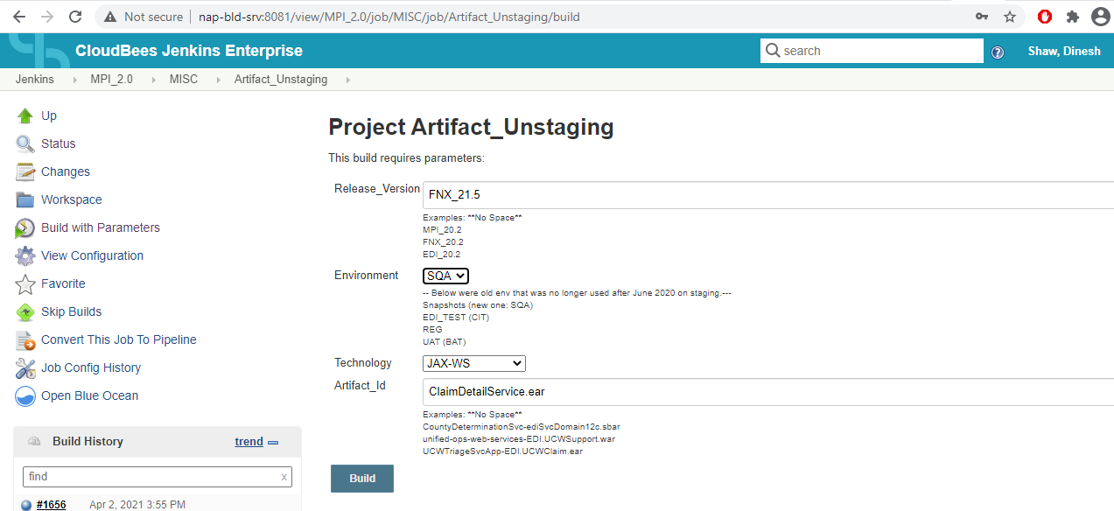

# 11. Setup Existing OSB service in J Developer

Create an OSB application in your workspace folder (Only create application not project) via J Developer.

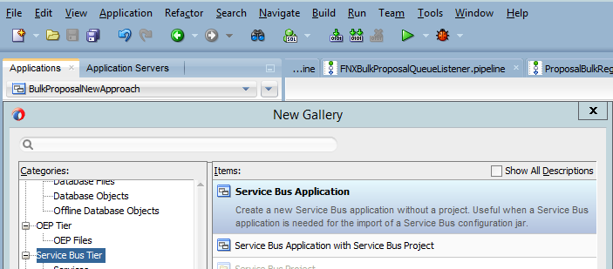

Now Check-out the existing OSB/SOA service from GIT inside this newly created application folder.

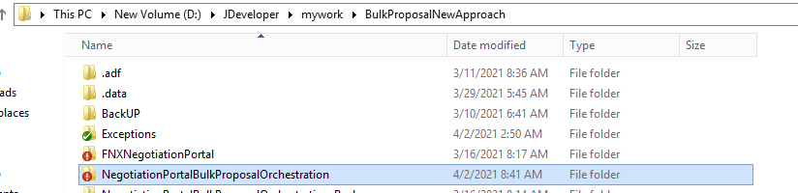

Now go to J Developer inside that newly created application and click on open project then go to inside the OSB project folder that you checked-in via GIT and select the project’s .jpr file and click on open.

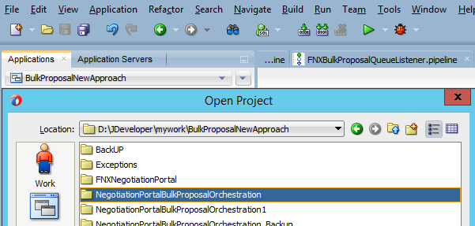

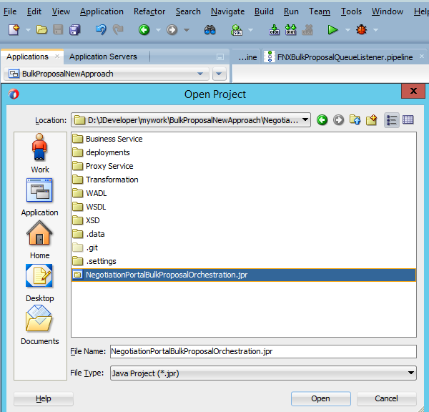

Your OSB project will be opened in J Developer.

Do the same thing for opening **ResourceNegSvc** OSB project in same OSB application in J Developer.

GIT Location: <http://gitscm.multiplan.com/OON/OSB/FNX/ResourcesNegSvc>

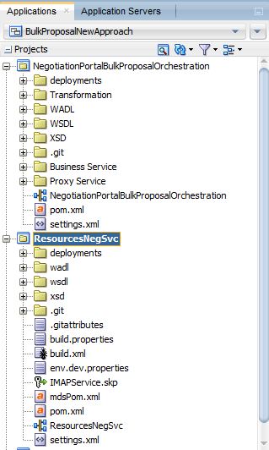

**ResourceNegSvc** is the OSB project where we put all common artifacts (WSDL, WADL, XSD etc.)

# 12. CR creation

We deploy codes into higher environment using Change Request (CR).

Go to this <url:-> <https://multiplan.service-now.com/nav_to.do?uri=%2Fsupport%2F>

Type “Change” in filter field and then click on **Create New**

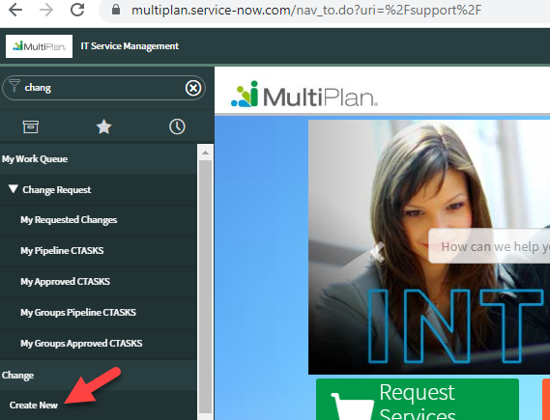

Select appropriate fields to create CTask

Update CTask and Run Staging/Deployment.

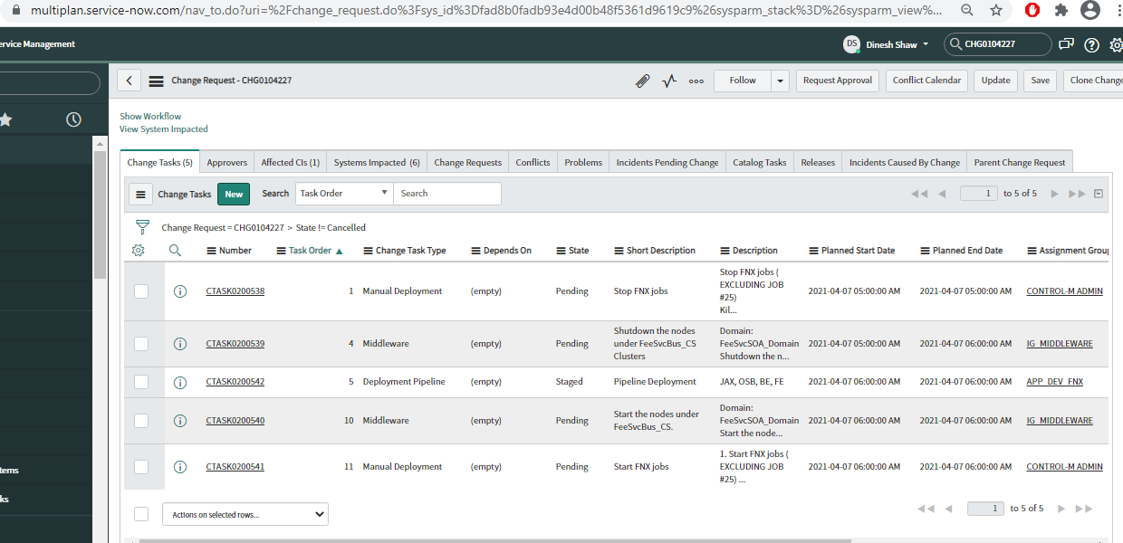

# 13. Overview of some of Existing Projects

## 13.1 **NegotiationPortalBulkProposalOrchestration**

This OSB project (**NegotiationPortalBulkProposalOrchestration**) is created for Bulk Proposal project.

Requirement Overview:- <https://confluence.multiplan.com/pages/viewpage.action?pageId=83925762>

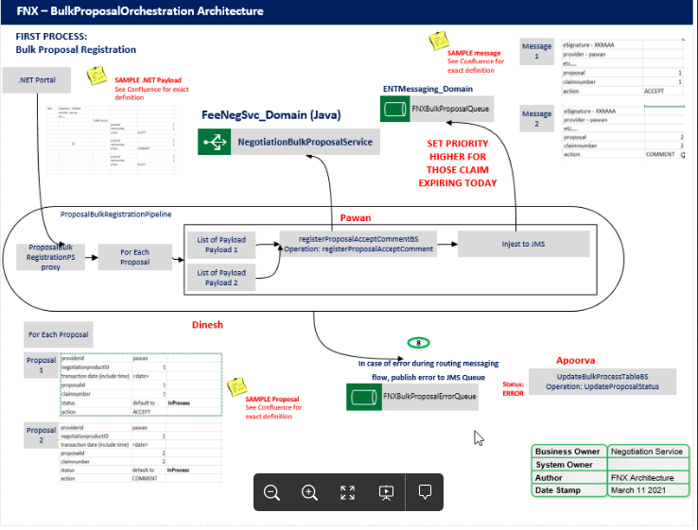

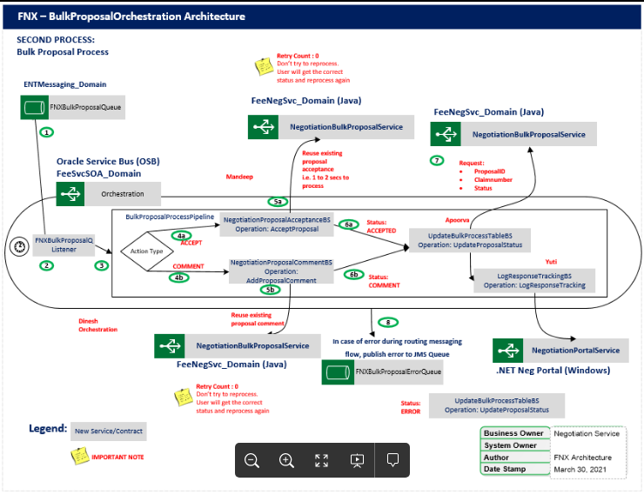

Follow the architecture design and service orchestration flow from above confluence page.

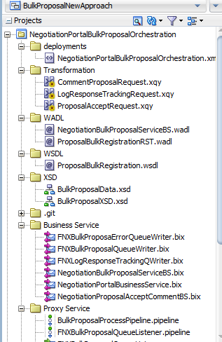 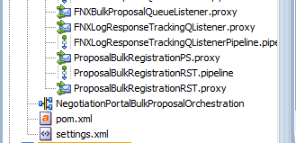

External Service invoked-

1. NegotiationBulkProposalService (JAX-RS)

2. NegotiationPortal Service (.net side)

3. Writing to FNXBulkProposalQueue.

4. Writing to FNXBulkProposalErrorQueue

5. Writing to FNXLogResponseTrackingQueue

Orchestration-

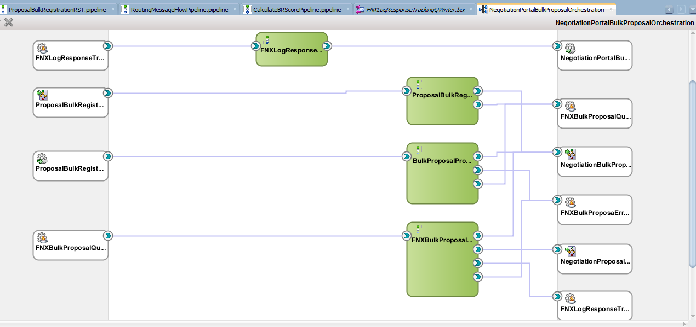

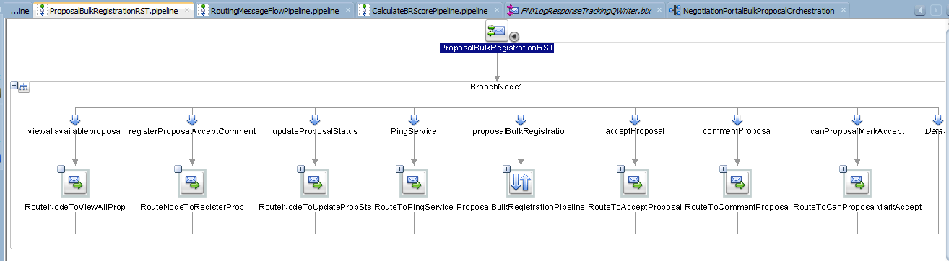1st Flow:- **ProposalBulkRegistrationRST.pipeline** This Pipeline connects to a REST Proxy to expose all operation as REST.

**ViewAllAvailableProposal**, **RegisterProposalAcceptComment** and **ProposalBulkRegistration** are the operations those are currently called by .net Portal FE.

Same flow is created by following SOAP method invocation:- **BulkProposalProcessPipeline.pipeline**

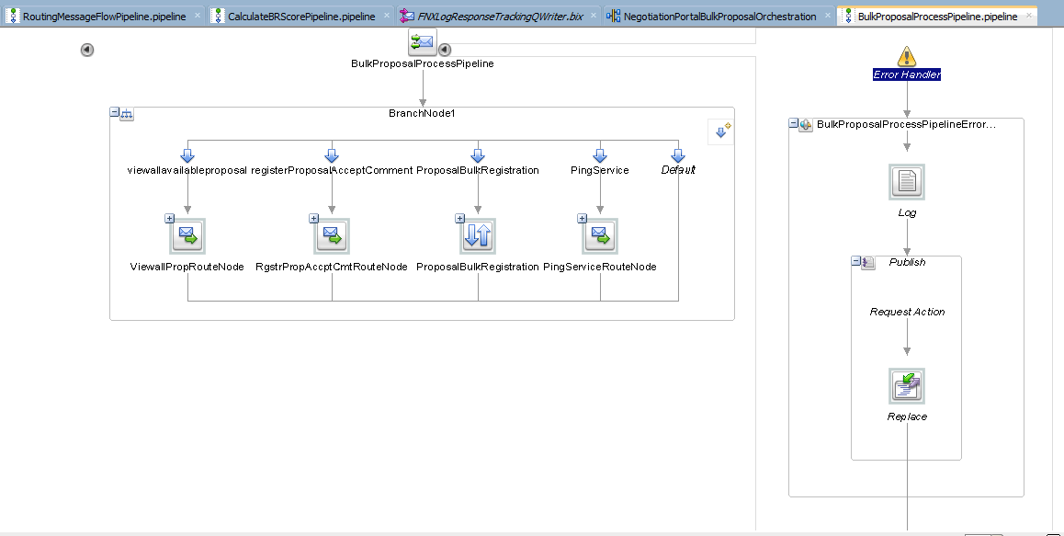

This Pipeline will be connected to a Proxy which will expose these operations as SOAP service.

2nd Flow:- **FNXBulkProposalQueueListener.pipeline**

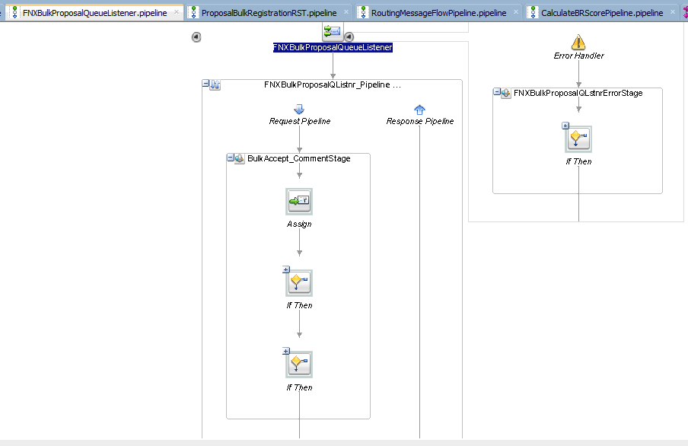

Above flow is initiated by JMS Queue Listener, which Listens to **FNXBulkProposalQueue** JMS Queue in **EntMessaging** Domain.

3rd Flow:- **FNXLogResponseTrackingQListenerPipeline.Pipeline** This flow is initiated by 1 JMS Queue Listener which listens to **FNXLogResponseTrackingQueue.**

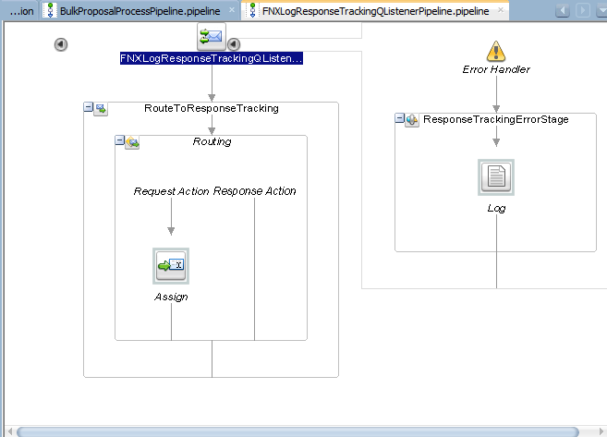

This flow invokes **LogResponsrtracking** operation part of **NegotiationPortal** .net service.

## 13.2 ProviderExclusionOrchestration

This service works as Pass through for ProviderExclusion Java service.

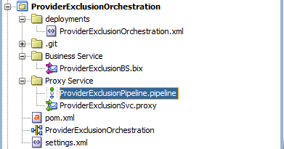 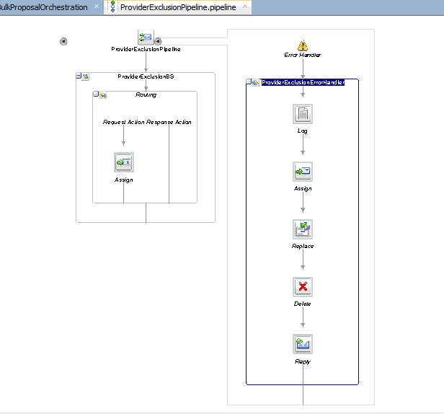

## 13.3 FNXSAPGuideline

This is pass through service for SapGuideline Java service.

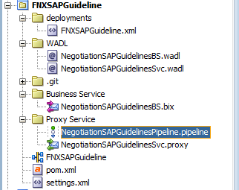

## 13.4 ClaimPrioritizationOrchestration

Objective of Claim Prioritization project is to determine claim priority based on a predicted and calculated Claim Priority Score (CPS)

Technical View-

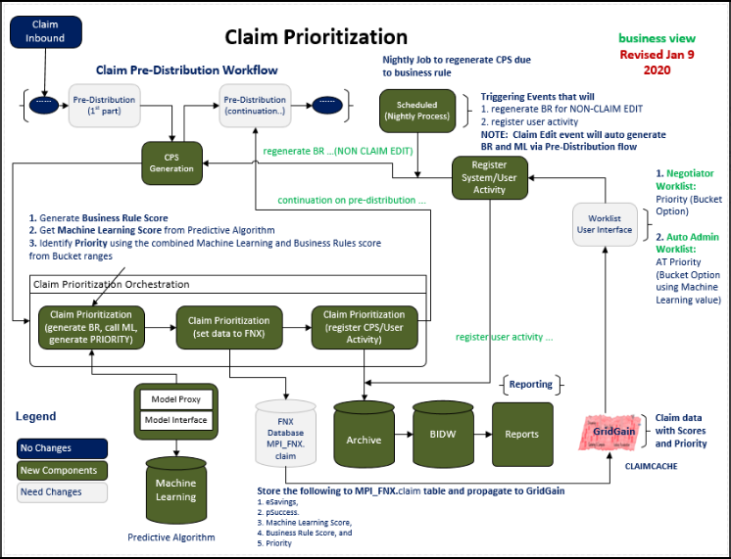OSB Changes

1. OSB AQ Listener will listen to the Oracle Advance Queue.

| Queue | Comments |
| --- | --- |
| MPI_AQADM.AQJMSPriorityScore_Q | Queue where FNX system enqueue the claim number eligible for claim priority scoring |

1. Call JAX-RS service, which will do “Data engineering” and it will give response in JSON format.
2. Now call another JAX-RS service for “Claim Prioritization” it will also give response as JSON data.
3. Now call JAX-RS service which will store
4. Claim Prioritization Score,
5. Machine Learning Score,
6. Business Rule Score and
7. Priority ID

into “MPI_FNX.Claim” table

1. Now Put the Payload into a new JMS Queue.
2. Create a JMS Listener which will listen from above created Queue.
3. Now call another JAX-RS service that will Archive the Claim and it’s details into some other DataBase.

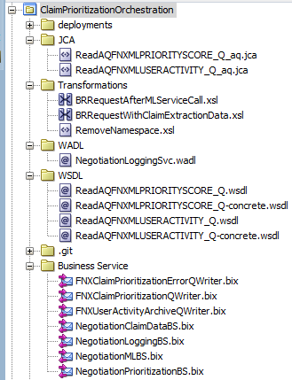Whenever a claim is picked up by the orchestration flow, it undergoes for validity check and set of five business rules is applied. Winner of all five rules is assigned as final business rule score. MachineLearning service is invoked to obtain final machine learning value. Using the combination of Final BR Score and ML Score priority is decided for a claim. All these values are stored in the system along with logs.

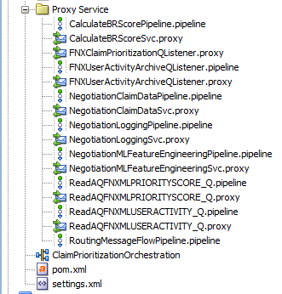

1. 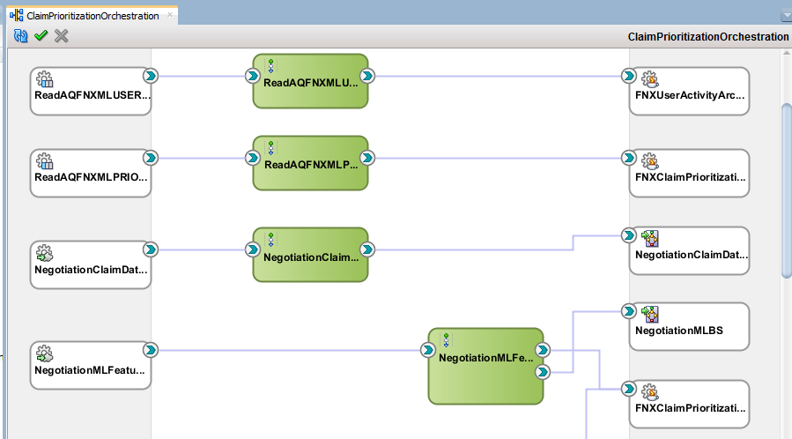 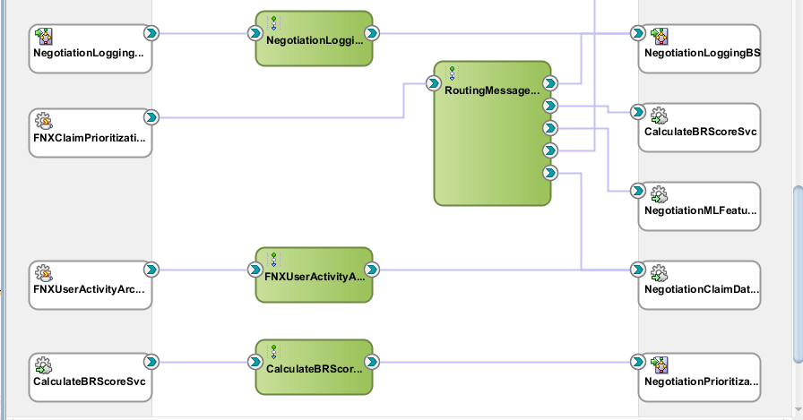

## 13.5 MachineLearningCPSOrchestration

This service invokes pSuccess and eSavings ML models.

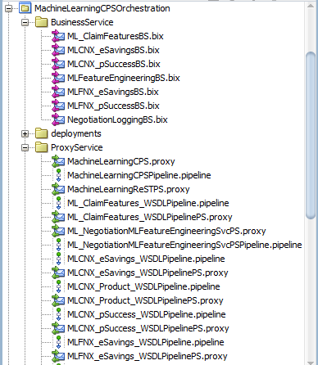 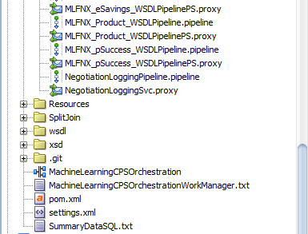

## 13.6 DistributionReWriteOrchestration

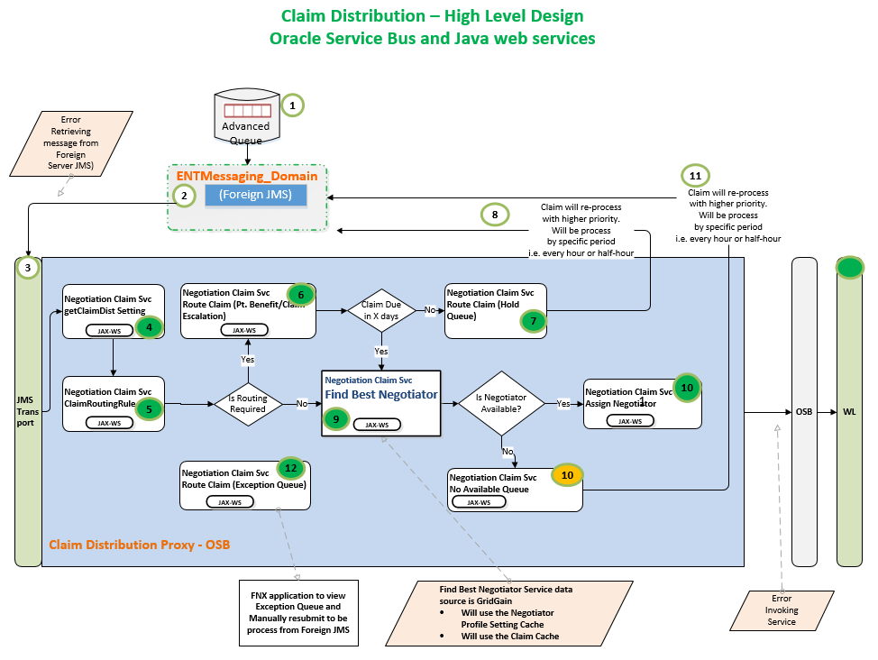

## 13.7 FNXNegotiationPortal

**Step1:** When user selects either email/Fax option from FE screen and clicks on send proposal then one entry of message is done in Oracle Advance Queue i.e. “MPI_AQADM.FAXPROXY_Q”.

**Step2:** Then at the same time OSB listener “FNXPortalFaxProxyQueueListener.proxy” picks the message and through it’s pipeline passes to “ProcessAQMessageocalProxy.pipeline”.

**Step3:** And “ProcessAQMessageocalProxy.pipeline” passes the message to BPEL and if there is any Fault in pipeline then message will be sent to “FNXProposalErrorQueue” JMS Queue.

**Step4:** Once BPEL “FNXNegotiationsBPELProcess.bpel” gets the request from OSB then it passes the proposal Id to “Proposal Java service” via GetProposal operation and gets details of proposal like System,Negotiator,Recipient,claimproposal details etc.

**Step5:** Next in the BPEL “Portal .net service” has been called to generate WebKey.It will return WebKey,Email URL,Fnx Url,directUrl, tease url, internal url.

**Step6:** Now call “Proposal Java service” using operation “”save Proposal

To save proposal details into proposal table. SP name “spSaveProposalWebDetails”.Here WebKey,Email URL,Fnx Url,directUrl, tease url, internal url are updated into Proposal table.

**Step7:** If selected communication method is email then save the document details into document and documentItem table through “SpSaveOutboundEmail” stored procedure by calling “Proposal Java Service” using operation “SaveOutboundEmail”.

**Step8:** If Email Once is set then do nothing else Get the no. of mails sent today by calling “Proposal Java Service” using “GetNumberofEmailSentToday” operation.Which hence calls stored Procedure “SfEmailSentToday” which fetches data from “EmailRepository” table.

**Step9:** If Email needed, emailOnce=1 and it is not reminder or provider needs one email today=true theninvoke “ProposalService” using “GetOutBoundEmailContent” operation.Which calls stored function “SfGetOutBoundEmailContent”.

**Step10:** Now if Clienttypecd=H then Concate ClaimType of subject else Bill in the subject of mail.

**Step11:** If it is a “Reminder” Mail then Concate Reminder in Email Subject else do nothing.

**Step12:** If use Alternate Email is “O” then send mail through “Notification-Service” using operation “SendEmail” else if Alternate Email is 1 then call “Proposal Java service” and use operation “SendProposalEmail” and it calls stored function “sfSendEmail”.

**Step13:** Now call “Proposal Java Service” using operation “UpdateDocumentStatus” which calls stored procedure “spUpdateDocumentStatus” and updates the details.

**Step14:** If selected communicationmethod is Fax(i.e. else part of step7) then call OSB proxy “FNXPortalFaxQueueWriterProxyService.Proxy” which at the end puts message into Oracle AQ, “FAX_Q”.

--------------------------------------:Bounce Back Email Handeling:------------------------------------------

# “EmailListenerProxy.proxy” Listens to “Ewa.multiplan.com:993” to account email Box (dev.view/sqa.view etc.) and “CNXEmailListenerProxy.proxy” listens to email Box (msadevportal/ MSASQAPortal etc.). Whenever any email is sent to [dev.view@multiPlan.com](mailto:dev.view@multiPlan.com)/Dev.Portal@marsauditor.com then these listeners will pick the emails from its respective email boxes and it will put the message into “FNXEmailErrorsQueue”.

# “FNXEmailErrorsQueueListener.proxy” listens to “FNXEmailErrorsQueue” JMS Queue.Whenever any message comes into this JMS Queue then this OSB Lustener picks and calls “HandleEmailErrorsRequest” operation of “Proposal Java Service”.

## 13.8 ResourcesNegSvc

This works as common artifactory service where all the common resources are saved like xsd, wsdl,transformation files etc.

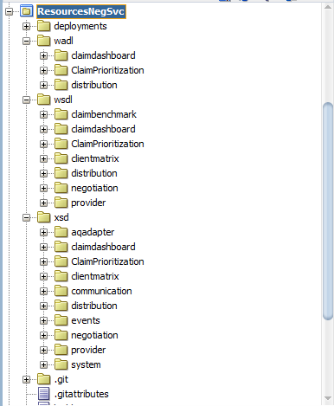

## 13.9 SOA Service (FNXNegotiations)

This SOA service is used to orchestrate the Proposal flow. Below flow is integrated in OSB (FNXNegotiationPortal), you can refer 13.7

Folder structure:

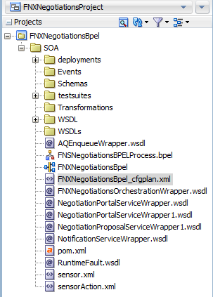

SCA composite:-

